**Mechi Multiple Campus**

(Tribhuvan University)

Bhadrapur, Jhapa



**Lab Report of**

**Data Structures and Algorithm (CACS-201)**

**Implementation of Searching Algorithm**

Faculty of Humanities & Social Sciences

Tribhuvan University

Kritipur, Nepal

**Submitted By**

**Name:** Santosh Bhandari

**Roll No:** 58

**Submitted To**

Mechi Multiple Campus

Department of Bachelor in Computer Application

Bhadrapur, Jhapa, Nepal

**Program Code**

#include<stdio.h>

void main(){

int n,num[50],i,loc=-1,data;

printf("How many Data You Want to Insert: ");

scanf("%d",&n);

for(i=0;i<n;i++){

printf("Enter a Number: ");

scanf("%d",&num[i]);

}

printf("Enter a Search Number: ");

scanf("%d",&data);

i=0;

while(loc==-1 && i<=n-1){

if(num[i]==data)

loc=i;

i++;

}

if(loc==-1)

printf("Search is Unsuccessful");

else

printf("Search is Successful at Location = %d",loc);

}

**Output of the Program**

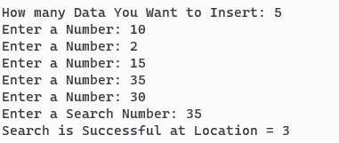

**Program Code**

#include<stdio.h>

void main(){

int n,num[50],i,data,beg,mid,end;

printf("How many Data You Want to Insert: ");

scanf("%d",&n);

for(i=0;i<n;i++){

printf("Enter a Number: ");

scanf("%d",&num[i]);

}

printf("Enter a Search Number: ");

scanf("%d",&data);

beg=0;

end= n-1;

mid=(beg+end)/2;

while(beg<=end && num[mid]!=data){

if(data<num[mid])

end=mid-1;

else

beg=mid+1;

mid=(beg+end)/2;

}

if(num[mid]!=data)

printf("Search is Unsuccessful");

else

printf("Search is Successful at Location = %d",mid);

}

**Output of the Program**

